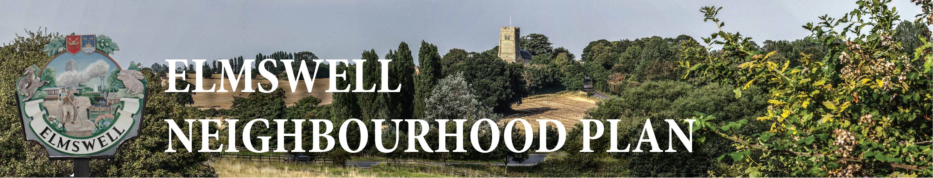

STEERING GROUP MEETING
Tuesday 17th February 2015
at The Blackbourne
Agenda
1 Apologies.
2 Approve minutes from 17th February.
3 Matters arising from the Minutes and not dealt with as an Agenda item.
4 Any further feedback from consultations with community groups & organisations.
5 Review latest draft of Household Questionnaire ready to OK printer – still unresolved:
5.1 Drop-off points for paper copies...someone needs to check with Library / Mace /
Co-op / P.O. / Fox etc?
5.2 Other practicalities?
5.3 Pop-up banners / signs
6 Confirmation of arrangements for questionnaires to Elmswell Primary / Thurston
7 Reports on recent NP seminars – Sarah,Peter D
8 Base line statistics
9 AOB for discussion, to be noted or for inclusion on a future agenda
10 Date for next meeting
11 Close
Peter Dow
17.03.15

